# **Allow SSH Root Access**

**Steps To Allow SSH Root Access:**

1. Go to /etc/ssh/ folder.

|  |
| --- |
| cd /etc/ssh/ |

1. Edit sshd_config file.

|  |
| --- |
| vi sshd_config |

1. Search for PermitRootLogin.

|  |
| --- |
| /PermitRootLogin |

1. Make sure that PermitRootLogin is set to yes and there is no # in front of it.

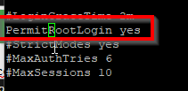

1. Now search for PasswordAuthentication and make sure that it is set to yes and there is no # in front of it.



|  |
| --- |
| /PasswordAuthentication |

1. After change, please make sure that you save it.
2. Now try to login by using Putty or any SSH client.
3. If you can login, it means you already success.

